Dave’s Loop
ALSO KNOWN AS SOUTHWEST OHIO COVERED BRIDGE TOUR

Starting at the KOA, turn right out of the campground onto Wellbaum.
Turn left on Wengerlawn. 1.2 miles
Turn right on Preble County Line Road. 5.1 miles
Immediately turn left on Swamp Creek Road and continue until you reach: 1.7 miles
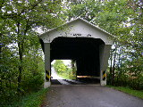
WARNKE BRIDGE OH-68-14 Childs Truss, built in 1895 is located NNE of Lewisburg on Swamp Creek Road (TR 403). The GPS location is Lat. 39.8738N & Long. -84.5148W.

Turn left on Verona Road. .2 miles
Turn right at the T. This is Route 40 west. 1.5 miles
Turn left on Commerce St. (OH 503). .4 miles
Turn left on Dayton St. .6 miles
At park entrance, turn left. Covered bridge is in the park on the right side: .2 miles
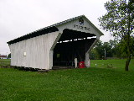
DIXON BRANCH BRIDGE OH-68-04 Childs Truss, built in 1887 is located at the eastern edge of Lewisburg at Cavitan Park, GPS is Lat. 39.84597, Long. -84.53587

Make a U-turn and leave the park, turning right onto E. Dayton St. .1 miles
Turn left on Western Ave., which becomes Lewisburg Western Rd. .2 miles
Continue straight on Lewisburg Western Rd. until it becomes Price Rd. This will take you directly to: 3.1 miles
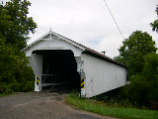.
GEETING BRIDGE OH-68-13 Childs Truss, built in 1894 is located west of Lewisburg on Price Road. The GPS location is Lat. 39.8433N & Long. -84.5970W.

Continue through the bridge and follow Price Rd. as it makes several turns.
When Price Rd. ends, turn left on 127 South. 2.3 miles
Turn right on Winnerline Rd. 1.1 miles
After 2 miles, Winnerline jogs to the left onto 726 and then back to the right. .2 miles
Turn left on Spacht Rd. .7 miles
Turn left on Eaton-New Hope Rd. 2.6 miles
Continue until you get to: 1.5 miles
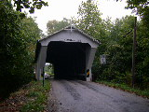
CHRISTMAN BRIDGE OH-68-12 Childs Truss, built in 1895 is located NNW of Eaton on Eaton/New Hope Road (TR 142). The GPS location is Lat. 39.7697N & Long. -84.6548W.

Turn right on Eaton Gettysburg Rd, which turns into Park Ave, which turns into Seven Mile, which turns into Water St. .1 miles
Turn right on Beech St, 2.3 miles and on the right side you will see: .05 miles
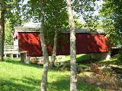
ROBERTS BRIDGE OH-68-05 Burr Arch Double Barrel Truss, built in 1829, damaged by arson in 1986 & later restored, is located in Eaton at Crystal Lake Park, off US 127. The GPS location is Lat. 39.7395N & Long. -84.6383W.

This is not a drive-thru bridge, so make a U-turn and turn left on Beech St.
Turn right on Israel. .05 miles
Turn right on S. Franklin (122 East). .34 miles
(For a stop at the URAL Rally and Open House, turn right on Quaker Trace Rd. 4.8 miles
Heindl Engineering will be on the left .45 miles
When leaving Heindl, turn right on Quaker Trace.
Turn right on 122 South .45 miles, then continue on the Covered Bridge Tour).
Turn sharp right on Brubaker Rd. 3.3 miles and continue until you reach: .6 miles
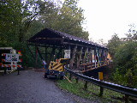
BRUBAKER BRIDGE OH-68-06 Childs Truss ,was built in 1887. The GPS location is Lat. 39.6517N & Long. -84.5438W.

Continue on Brubaker Rd as it turns to the left. .6 miles
Turn left at the T (725 East) .5 miles
Turn left on Water St. 10.5 miles
Turn right on E. Center St. .08 miles and continue until you get to: .04 miles
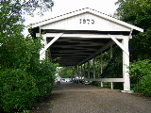
GERMANTOWN BRIDGE OH-57-01 Inverted Bowstring Truss, built in 1870 is located at Germantown on East Center Street. The GPS location is Lat. 39.6262N & Long. -84.3650W.

This is not a drive-thru bridge. Make a U-turn and turn right on Water St. .04 miles
Turn left on Dayton Pk. .04 miles
Turn right on Cherry St. .2 miles
Veer right on Diamond Mill Rd. 1 mile
Turn left on Upper Lewisburg-Salem Rd. 14.4 miles
Turn right on Wellbaum. 1.1 miles
KOA campground will be on your right. .8 miles

